# C:\Users\Messom\Desktop\Monash.jpg

# FIT5032 Learning Summary Report

# 

STUDENT NAME: 25368974

Self-Assessment Details

The following checklists provide an overview of my self-assessment for this unit.

|  |  |  |  |  |
| --- | --- | --- | --- | --- |
|  | Pass | Credit | Distinction | High Distinction |
| Self-Assessment (please tick) |  |  |  | √ |

*Self-assessment Statement*

|  |  |
| --- | --- |
|  | Included (please tick) |
| Learning Summary Report | √ |
| Progress on Pass Tasks | √ |
| ASP.NET C# applications that demonstrate coverage of core concepts | √ |

*Minimum Pass Checklist*

|  |  |
| --- | --- |
|  | Included (please tick) |
| Progress on Credit Tasks | √ |
| All Pass Tasks signed off in Doubtfire | √ |
| Assignment Application meets Credit Requirements (or more) | √ |

*Minimum Credit Checklist, in addition to Pass Checklist*

|  |  |
| --- | --- |
|  | Included (please tick) |
| Credit and Pass Tasks done, and Progress on Distinction Tasks. | √ |
| Assignment Application meets Distinction Requirements | √ |
| Design report meets Distinction Requirements | √ |

*Minimum Distinction Checklist, in addition to Credit Checklist*

|  |  |
| --- | --- |
|  | Included (please tick) |
| Research report meets High Distinction Requirements | √ |

*Minimum High Distinction Checklist, in addition to Distinction Checklist*

# Declaration

I declare that this learning summary and the linked portfolio of work is my individual work. I have not copied from any other student’s work or from any other source except where due acknowledgment is made explicitly in the text, nor has any part of this submission been written for me by another person.

Signature: Haomai Li

# Introduction

This report summarises what I learnt in FIT5032 Internet Applications Development. It includes a self-assessment against the criteria described in the unit outline, a justification of the pieces included, details of the coverage of the unit’s learning outcomes, and a reflection on my learning.

# Overview of Pieces Included

This section outlines the pieces that I have included in my portfolio.

1. Task 3.1 – 3.3 More ASP.NET Server Controls File, button controls and labels control.
2. 4.1 basics: data types and operators. Some basic C# knowledge, just like java nd C++, etc.
3. 4.2 language constructs, I need to think a lot about methods.
4. 5.1 Master Pages. This is a main function used in APS.net, which can format most of the pages using one setting.
5. 6.1 Validation controls. Input validation, prevent database and system logical.
6. 7.1 Using Data stores-Access. Using access to design a database for the system.
7. 8.1 – 8.2 Data controls. Edit and delete from website, which interact with database.
8. Assignment 1, using Master page to format website, allow user register.
9. Assignment 2, mainly focus on interact with database.
10. Assignment 3, using MVC make website more reliable.
11. Research report, my research report is about Responsive web design. It is a technique used for swapping PC website to mobile devices.

# Coverage of the Learning Outcomes

This section outlines how the pieces I have included demonstrate the depth of my understanding in relation to each of the unit’s learning outcomes.

## LO 1: demonstrate the impact of the history of web applications development on current web-technology;

The following pieces demonstrate my ability in relation to this LO:

* Test 1.2 Hellowworld.aspx demonstrates that html is not the only front side language for web development.

## LO 2: design, construct and publish web-database applications;

The following pieces demonstrate my ability in relation to this LO:

* Test 2.1 demonstrate that I have ability to design a database for a specific case.
* Test 7.1 demonstrate that I can design a database by using Access.
* Test 8.1, 8.2 demonstrate that I can make website interact with my databse.

## LO 3: analyse and critique the key technological issues confronting developers building web-database applications;

The following pieces demonstrate my ability in relation to this LO:

* Test 5.1 demonstrate that format pages can save a lot of time.
* Test 8.1, 8.2 is about data control, from the access database, implement edit and delete data. I learnt that use grid to deal with data.

## LO 4: test the key features of programming languages which are commonly used for developing web-database application;

The following pieces demonstrate my ability in relation to this LO:

* The key feature of C# used for developing web-database application is Gridview and Datasource
* Another feature for developing web-database application is combined SQL and C#

## LO 5: assess the MVC design pattern and construct a web-database application using the MVC design pattern;

* A controller is responsible for handling incoming requests to an ASP.NET MVC appliction and determines what response to send back to a user. A controller is just a class. Our example application includes a controller named HomeController.cs located in the Controllers folder.
* jQuery has a built in hover function that can be used to change the colour of tables rows as users move the mouse over them.

## LO 6: apply, analyse and critique a professional approach towards the development of web-database applications.

The following pieces demonstrate my ability in relation to this LO:

* …
* …

# Reflection

## The most important things I learnt:

1, I leant how to design a master page and apply it to other pages in a website, the syntax and the ideas.

ASP.NET Master pages can control every aspect of a page except those areas designated to contain variable content. Master pages therefore could be considered true templates.

A single Master Page can define the look, feel and standard behavior that the developer wants for all pages or groups of pages, in an application. The developer can then create individual Content Pages that contain the content to be displayed. When a user requests a Content Page, it is merged with the Master Page to produce output that combines the layout of the Master Page with the content from the Content Page.

The code for master page :

<%@ Master Language="C#" %>  
<html>  
 <head runat="server">  
 <title></title>  
 </head>  
 <body>  
 <h3>The Master page</h3>  
 <form id="form1" runat="server">  
 <asp:ContentPlaceHolder ID="ContentPlaceHolder1"   
 runat="server" />  
 </form>  
 </body>  
</html>

The code for content page :

<%@ Page Language="C#" MasterPageFile="example0101.master"  
 Title="ASP.NET Master Page Example"%>  
  
 <asp:Content ID="Content1"   
 ContentPlaceHolderID="ContentPlaceHolder1" runat="server">  
 <asp:Label ID="lbl1" runat="server"   
 Text="This is the content page"/>  
</asp:Content>

2, How to use theme and skin to make pages more beautiful (.CSS and .SKIN files)

Applying a theme to a web site means styling the site so that all the pages have a similar look and feel in text, colour and layout generally. Themes are like a more advanced form of stylesheets. The example shown demonstrates the use of serveral different themes applied to a website.

3, Connect to database and database control

DataSource controls were introduced in ASP.NET 2.0. These controls create an additional layer of abstraction between ASP.NET and the underlying Data Providers which talk to the actual datastore. This means that rather than having to write code to connect to a datastore, issue an SQL command and then retrieve the results, these steps can be carried out using standard ASP.NET control syntax. Once a data source control has been properly configured, it can be bound to any data Web control, which we will cover later. When the page is visited, the data Web control will automatically invoke the associated data source control, retrieve its data, and display it as configured. However, it is important to note that behind the scenes, the data source controls are actually performing quite a lot of steps, however, the complexity is hidden from the developer.

Adding an AccessDataSource control.

<%@ Page Language="C#" Debug="true" %>  
  
<asp:accessdatasource runat="server" id="dsAccess"   
 DataFile="BillnBen.accdb"   
 SelectCommand="SELECT * FROM product_details" />  
  
<html>  
 <head>  
 <title>Product List</title>  
 <link rel="stylesheet" type="text/css" href="style.css">  
 </head>  
 <body>  
 <center>  
 <h3>Product Details</h3>  
 <form runat="server">  
 <asp:GridView ID="gvProducts" runat="server"  
 DataSourceID="dsAccess" />  
 </form>  
 </center>  
 </body>  
</html>

For access database we have to use label:

<asp:accessdatasource runat="server"></asp:accessdatasource>

4, Adding calendar to website

When the page loads the database can be checked to determine if there any events scheduled for today. If so, todays date can be highlighted in the calendar control by using a different background colour and a label below the calendar should display the event description and the event time. If there are no events for the current date, the label can show something else:

<asp:Calendar runat="server" ID="Calendar1" OnDayRender="DayRender"

BackColor="White" BorderColor="#999999"

DayNameFormat="Shortest" Font-Size="0.8em"

ForeColor="Black" Height="200px" Width="100%">

<SelectedDayStyle BackColor="#8C8EAA" Font-Bold="True"

ForeColor="White" Font-Size="0.8em" />

<SelectorStyle BackColor="#8C8EAA" Font-Size="0.8em" />

<WeekendDayStyle BackColor="#F3F3F6" Font-Size="0.8em" />

<OtherMonthDayStyle ForeColor="#8C8EAA" Font-Size="0.9em" />

<NextPrevStyle VerticalAlign="Bottom" Font-Bold="True"

ForeColor="White" Font-Size="0.8em" />

<DayHeaderStyle Font-Bold="True" Font-Size="0.8em"

BackColor="#D2D5DE" />

<TitleStyle BackColor="#8C8EAA" BorderColor="Black"

Font-Bold="True" ForeColor="White" Font-Size="0.9em" />

<DayStyle Font-Size="0.8em" />

</asp:Calendar>

<br/>

<asp:Label runat="server" ID="Event" ForeColor="red" />

<br />

<asp:Label runat="server" ID="Result" ForeColor="red"/>

<br />

<asp:Label runat="server" ID="Result1" ForeColor="red"/>

<asp:AccessDataSource ID="dsEvent" runat="server" DataFile="CustomerTable.accdb"

SelectCommand="SELECT * FROM [CalenderEvent] ORDER BY [ID]"></asp:AccessDataSource>

</td>

## The things that helped me most were:

The things that helped me most are my tutors` support and consultations. The tutors would like help us figure out what I misunderstand and what we cannot fix on our programs. And the resources on moodle, this unit gives most plenty resources to students. For other units, I used to get limit resources from lecture, this one is different.

## I found the following topics particularly challenging:

I found mobile Internet application is challenge, video internet application and search engine is challenge as well.

## I found the following topics particularly interesting:

I believe those challenging topics are interesting as well. But there are some more interesting topics, such as social network application, graphical-driven websites, etc.

## I feel I learnt these topics, concepts, and/or tools really well:

I feel for the first a few weeks, all the topics, concepts, and tools are easy to understand. Even the first assignment takes time. But for the last few weeks, it was getting harder, some concepts such as MVC, database implementation, if we did do it before, it was not so easy to learn.

## I still need to work on the following areas:

For the next part, I may have to study about mobile knowledge, which related to Internet application. In my research report, I have already tried to explore some important things in this area.

## My progress in this unit was …:

Because I aimed at HD for Doubtfire tasks, I was trying to do every task best. For each task, I would demonstrate my ability. So at the end of this semester, I finished every task( because I have not submitted this assignment, the T11.1 is unfinished, it will be finished once I submitted my assignment 3).

What is more, I believe this tasks can help us improve still and enhance our knowledge.

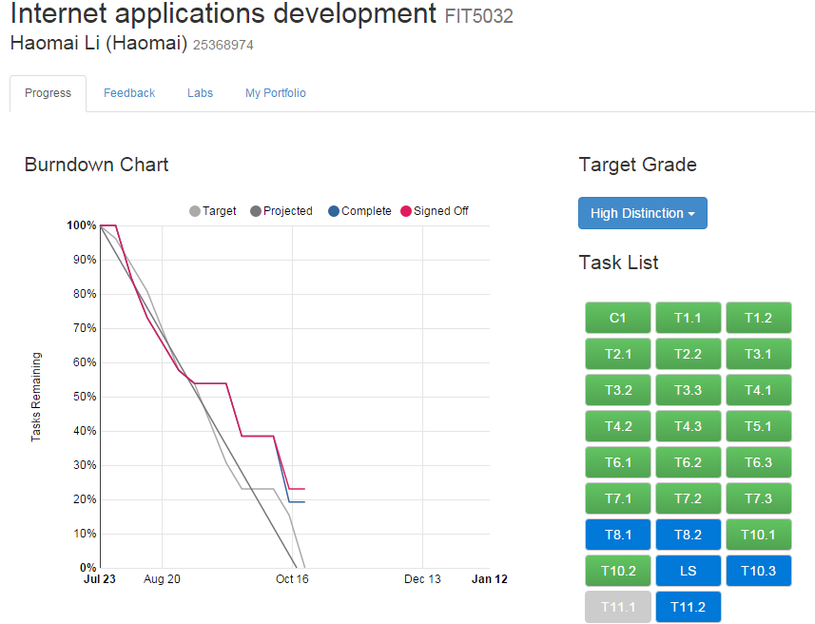

## This unit will help me in the future:

1. I can demonstrate the impact of the history of web applications development on current web-technology;
2. I can design, construct and publish web-database applications;
3. I would analyse and critique the key technological issues confronting developers building web-database applications;
4. I am able to test the key features of programming languages which are commonly used for developing web-database application;
5. To assess the MVC design pattern and construct a web-database application using the MVC design pattern;
6. I can apply, analyse and critique a professional approach towards the development of web-database applications.

## If I did this unit again I would do the following things differently:

If I would do this unit again, I will more focus on MVC, because I have knowledge in web forms, so MVC is more important.

## Other…:

This is a wonderful unit, which not only gives us opportunity on developing own website, but also encourage us to do some search. Both practical and academic values are in this unit.